**HTML and CSS Report for "Contact Now" Form  
This report details the design and functionality of the "Contact Now" form, which was created using HTML and CSS. The design incorporates form inputs, icons, and various formatting elements to create a structured and interactive contact form for users.**

**1. HTML Structure  
The HTML structure consists of several key sections:**

* **HTML Metadata: The document begins with the <!DOCTYPE html> declaration, setting the document type to HTML5. The lang attribute is set to "en" for English, and the <title> tag defines the page title as "Contact Now Form". The Font Awesome library is linked via <link> for adding social media and other icons.**
* **Head Section: The head section includes the <link> to the external CSS file (style.css) and the link to Font Awesome for icons.**
* **Body Structure: The <body> section contains three main divisions:**
  + **Header: A placeholder header area with no specific content.**
  + **Main Form: This is divided into two panels:**
    - **Left Panel: Includes the form header ("Contact Now"), input fields for Username, Password, Department, and Message, and a "Send Message" button.**
    - **Right Panel: Contains the following:**
      * **A Header Section with four social media icons (Facebook, Twitter, Futbol, Google Plus) wrapped in colored boxes.**
      * **A series of Input Containers, each containing an input element and corresponding icon. It also includes a dropdown select element for selecting a department and a large textarea for messages.**
  + **Footer: A placeholder footer area with no specific content.**

**2. CSS Design and Styling  
The CSS file (style.css) is linked to the HTML document to provide styling for the form elements. Key design elements include:**

* **Global Styling (*): Margins and padding are reset to ensure consistent rendering across different browsers.**
* **Body:**
  + **Background color: Default to white.**
  + **Overflow: Hidden to prevent scrollbars from appearing.**
  + **Flexbox Layout: Used to create a vertically centered layout, allowing for a balanced distribution of elements.**
* **Containers:**
  + **Header and Footer: Given a uniform gray background with specified heights for visual separation.**
  + **Main Form: Has a light gray background with margin spacing.**
  + **Left Panel: Styled with a light blue background color. The input fields and the "Send Message" button use a lighter shade of blue, with white placeholder text.**
  + **Right Panel: Bordered to visually separate it from the left panel. Contains various sections such as a header with social media icons and input containers for user interaction.**
* **Form Elements:**
  + **Input Fields: Styled with light blue backgrounds and white text. The placeholders have reduced opacity for a subtle look. The button follows a similar design with hover effects for interactivity.**
  + **Icons: Included within the input fields to provide visual cues. These icons are color-coded to match the overall design theme.**
* **Social Media Icons:**
  + **Positioned within colored boxes (blue, light blue, pink, and gray) to provide easy identification.**
* **Dropdown and Textarea:**
  + **Dropdown: Styled with padding and a border for uniformity with the other form elements.**
  + 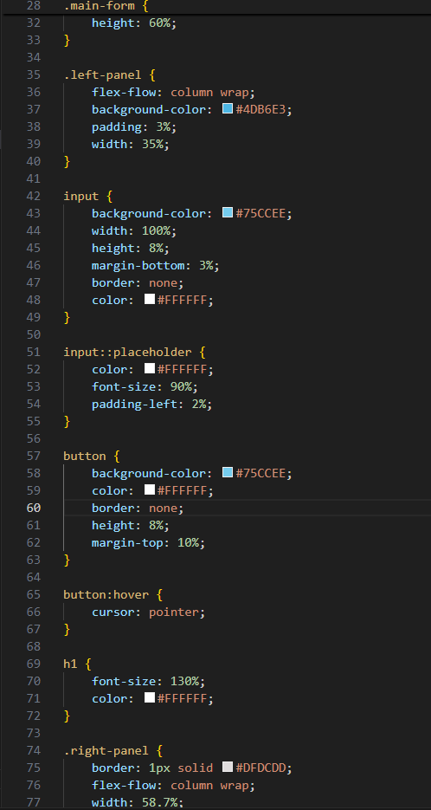**Textarea: Given a border and margin for spacing, allowing users to enter larger text.**

**3. Functionality  
The form provides fields for user input and several interactive elements:**

* **Input Fields: Fields for entering a username, password, department, and message.**
* **Icons: Representing the social media platforms in the header.**
* **Button: A "Send Message" button that users can click to submit their information.**
* **Dropdown and Textarea: Allow for selecting a department and entering longer messages, respectively.**

**Additional features include:**

* **Placeholder text in all input fields to guide users on what information to enter.**
* **Interactive hover effects on the "Send Message" button for better user experience.**

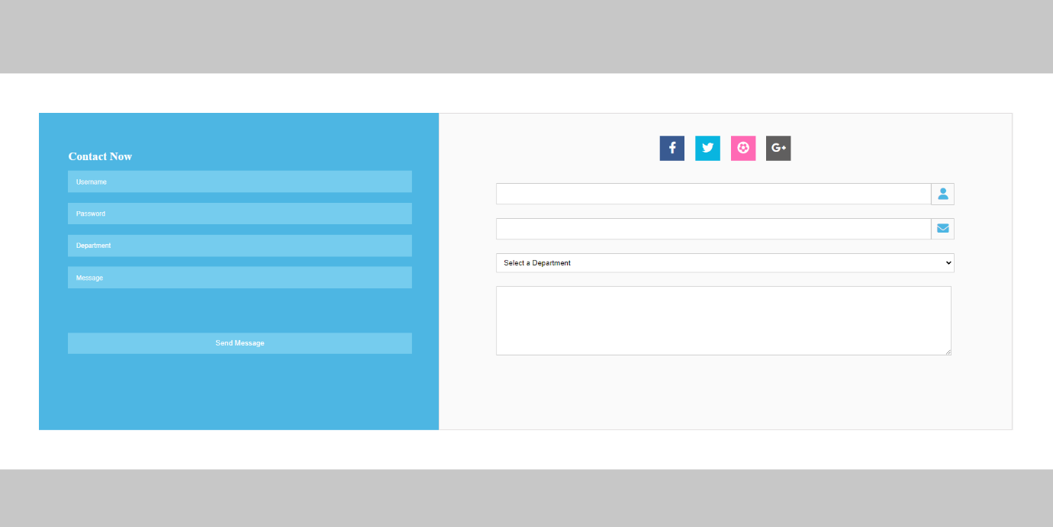

**HTML and CSS Report for Calculator Interface  
This report details the design and functionality of a calculator interface created using HTML and CSS. The design incorporates button groups, a display section, and various formatting elements to create a structured, user-friendly calculator layout.**

**1. HTML Structure  
The HTML structure consists of several key sections:**

* **HTML Metadata: The document starts with the <!DOCTYPE html> declaration, setting the document type to HTML5. The lang attribute is set to "en" for English, and the <title> tag defines the page title as "Calculator". The stylesheet (style.css) and Font Awesome icons library are linked via <link> tags.**
* **Body Structure: The <body> section is structured as follows:**
  + **Header:**
    - **Left Section: Includes two Font Awesome icons (hamburger menu and grid layout) along with a title labeled "Standard" to indicate the calculator mode.**
    - **Right Section: Includes a history icon to indicate a view for past calculations.**
  + **Main Section:**
    - **Display Section (constant): Displays the current value or input entered by the user.**
    - **Button Groups: Several button sections are present for different functionalities:**
      * **Memory Buttons (m-btn-group): Includes buttons for memory operations like MC, MR, M+, M-, MS, and M↓.**
      * **Action Buttons (second-btn-group and third-btn-group): Buttons like %, CE, C, division, and power operations.**
      * **Number Buttons (fourth-btn-group, fifth-btn-group, sixth-btn-group, seventh-btn-group): Number inputs from 0-9, arithmetic operators (+, -, *, /), and function keys like = and ..**

**2. CSS Design and Styling  
The CSS file (style.css) provides styling to the calculator interface. Key design elements include:**

* **Global Styling (*):**
  + **Background Color: A dark gray (#202020) that contrasts well with the white text color (#FFFFFF).**
* **Body Layout:**
  + **The main section occupies 90% of the viewport height (vh), providing ample space for the calculator elements.**
  + **Flexbox is used to arrange elements vertically and to ensure even spacing between them.**
* **Header and Display (constant):**
  + **Header: Uses flex-wrap to align its elements (hamburger icon, Standard text, grid icon, and history icon) horizontally. The left portion is set to take up 30% of the width.**
  + **Display Section (constant): A large area styled to display the current input value with text aligned to the right and a font size of 6rem for easy visibility.**
* **Button Styling:**
  + **All buttons (.m-btn, .color-1, .color-2, .color-3) have:**
    - **Border Radius: Set to 5px for smoother edges.**
    - **No Border: A minimalist look with no button outlines.**
    - **Consistent Widths: Memory buttons (m-btn) take up 16.6% of the width, while other buttons occupy 24.7%.**
  + **Button Groups:**
    - **Memory buttons (m-btn-group) have a height of 3%, while the other button groups (second-btn-group to seventh-btn-group) have a height of 6%.**
  + **Color Variants:**
    - **Grey Buttons (m-btn-grey): Used for memory buttons like MC and MR. They have a gray color to indicate non-primary actions.**
    - **White Memory Buttons (m-btn-white): Lighter shade buttons, including M+, M-, MS. These have hover effects that change their background color to a darker gray (#2D2D2D).**
    - **Numbers (color-1): Button background set to #3B3B3B. On hover, the background changes to #323232 to indicate selection.**
    - **Operations (color-2): Button background set to #323232 and hover to #3B3B3B to show active states.**
    - **Equals (color-3): A distinctive color (#7D8D96) to draw attention to the final action. On hover, the color slightly darkens to #73818A for visual feedback.**

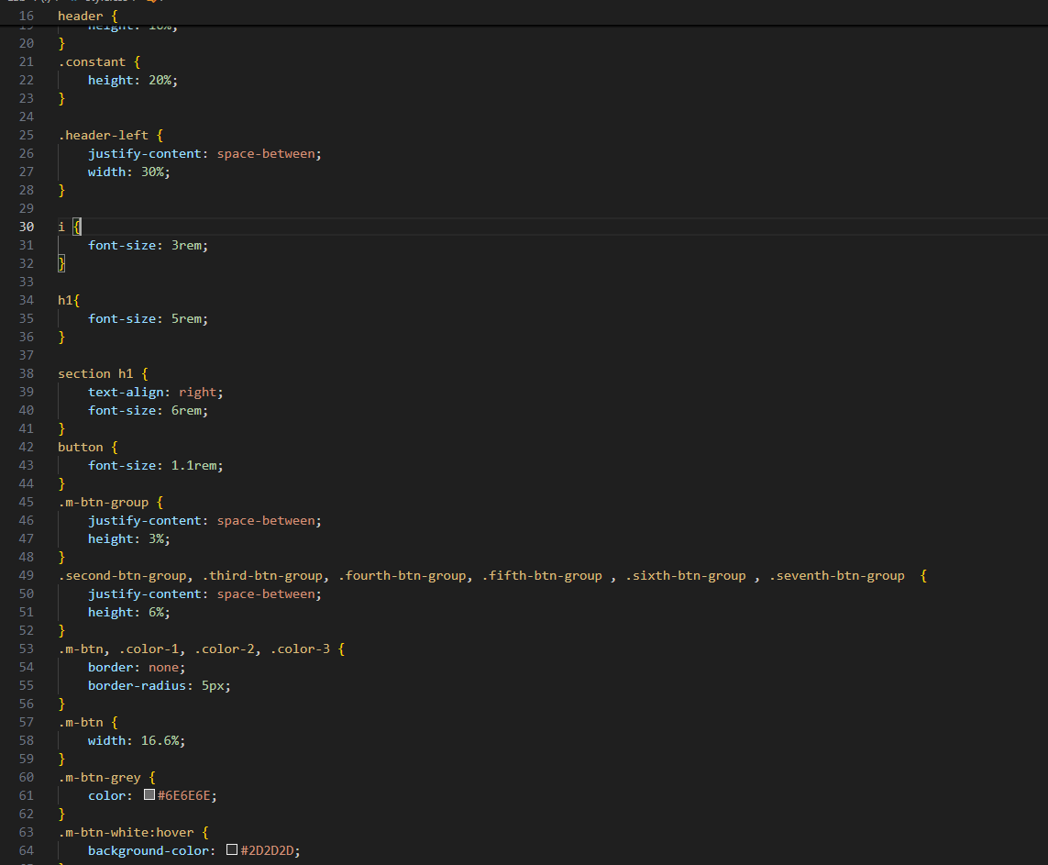

**3. Functionality  
The calculator interface provides all standard calculator functionalities through the use of buttons arranged in groups. Functional elements include:**

* **Display Section (constant): Displays the user's current input or output after performing an operation.**
* **Memory Buttons:**
  + **MC, MR, M+, M-, MS, M↓: These buttons allow users to store, recall, add to, subtract from, and clear memory.**
* **Operation Buttons:**
  + **Action Buttons: Include C (clear), CE (clear entry), % (percentage), and √ (square root).**
  + **Arithmetic Operators: Include division (÷), multiplication (X), subtraction (-), and addition (+).**
* **Number Buttons and Final Operation:**
  + **Numbers (0-9) and symbols like . (decimal point) and +/- (toggle positive/negative).**
  + **Equals Button (=): Executes the calculation, styled distinctively to emphasize its importance.**

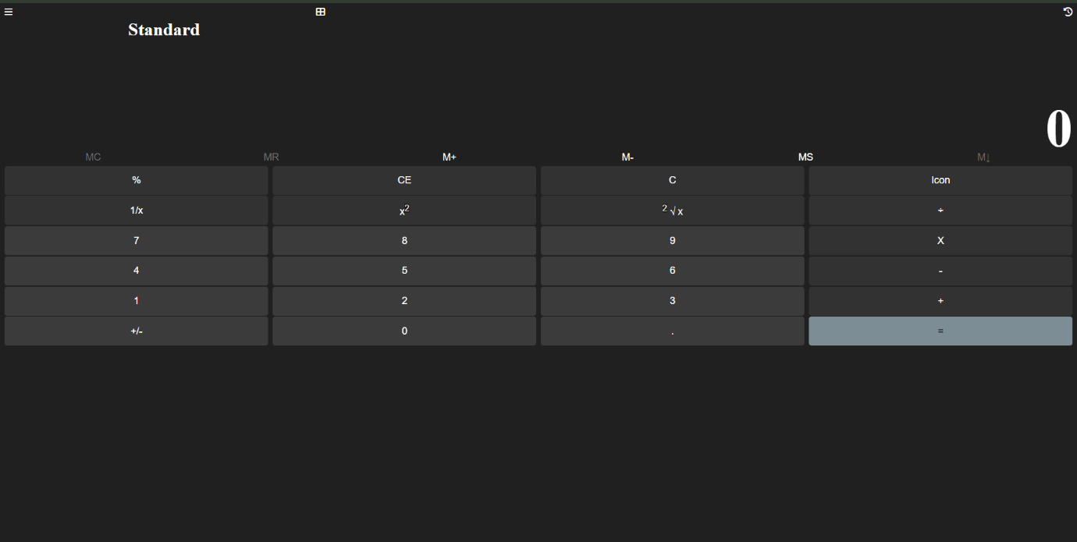

**Google Drive Link**: https://drive.google.com/drive/folders/1tK0O25hK0_1WUQWrU1xrOWUMHFj5pmbb?usp=drive_link